AI Demand & Supply Balancer – Mobile App Requirement
We already have a web-based Final Year Project called AI Demand & Supply Balancer – Intelligent Inventory Forecasting System.
We need a User Mobile Application as an additional module for our FYP. The mobile app should connect with the existing system for users.
- Customer Mobile Application:
Develop a user-friendly mobile application for customers to:
- Create accounts and log in securely.
- Place orders directly through the app.
- View order history and track order statuses.
- Update personal information and preferences.

- User Portal Screenshots:

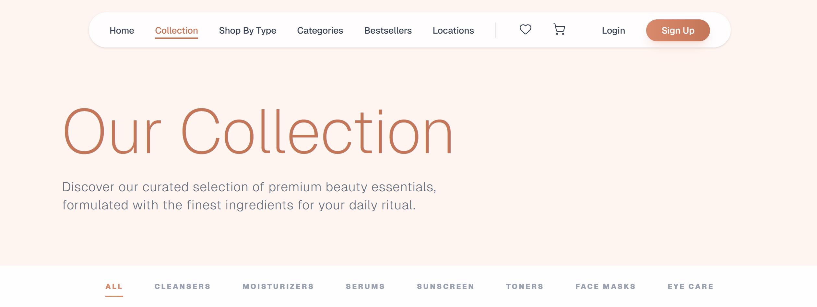


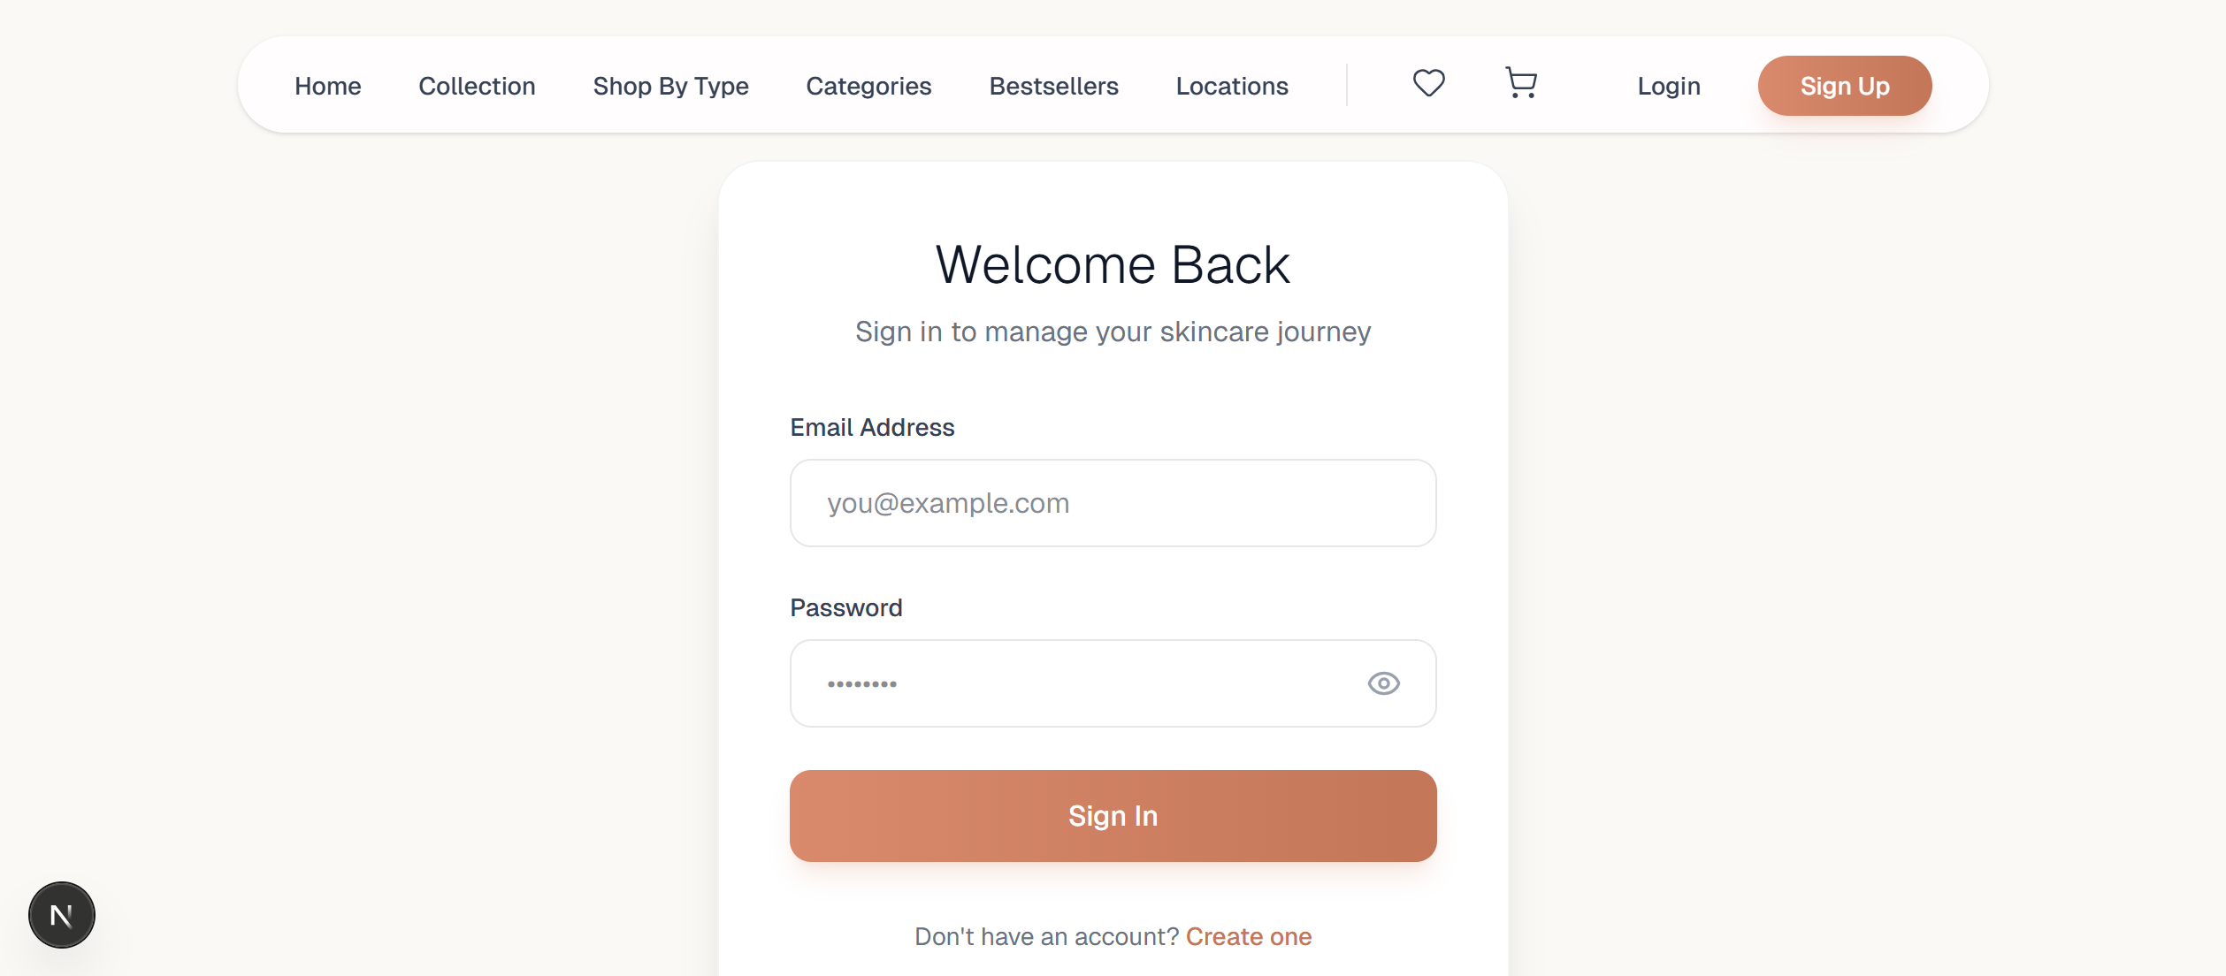
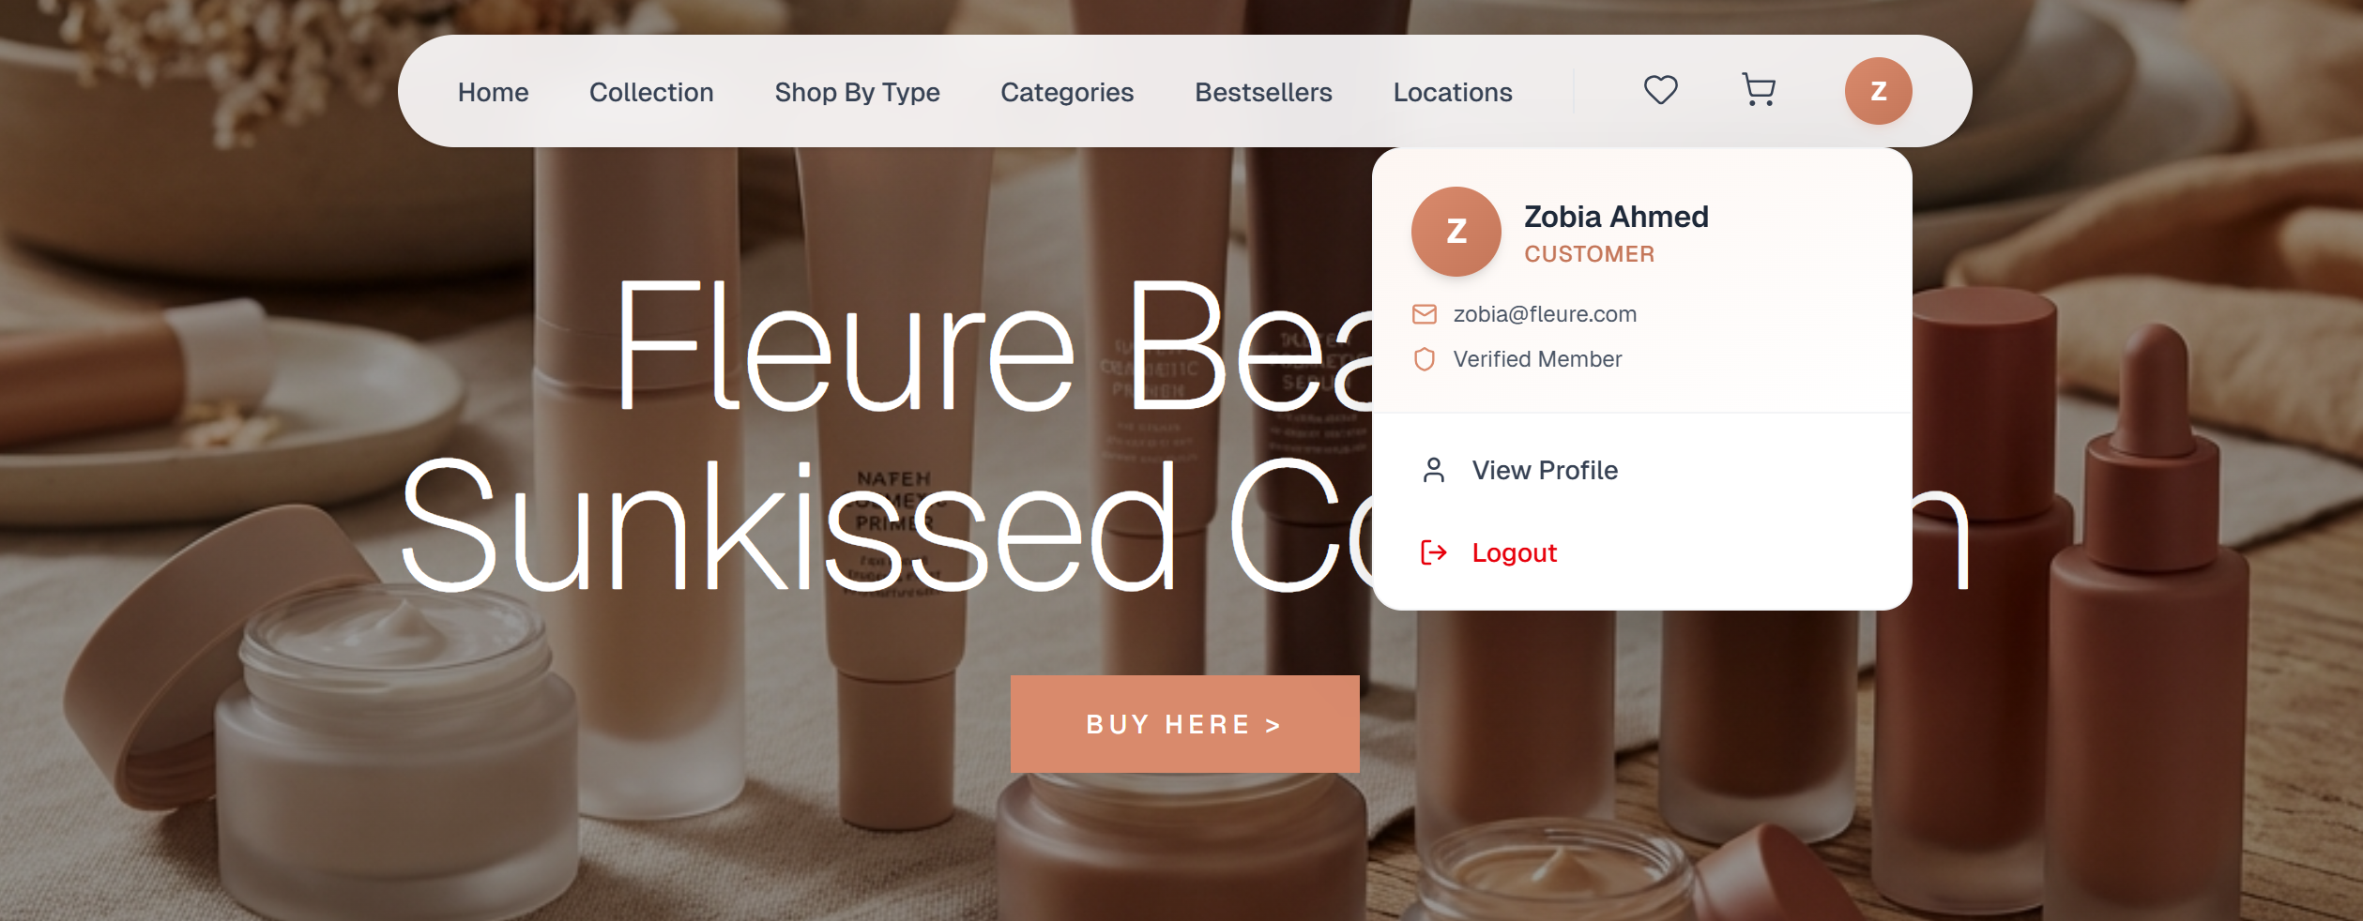
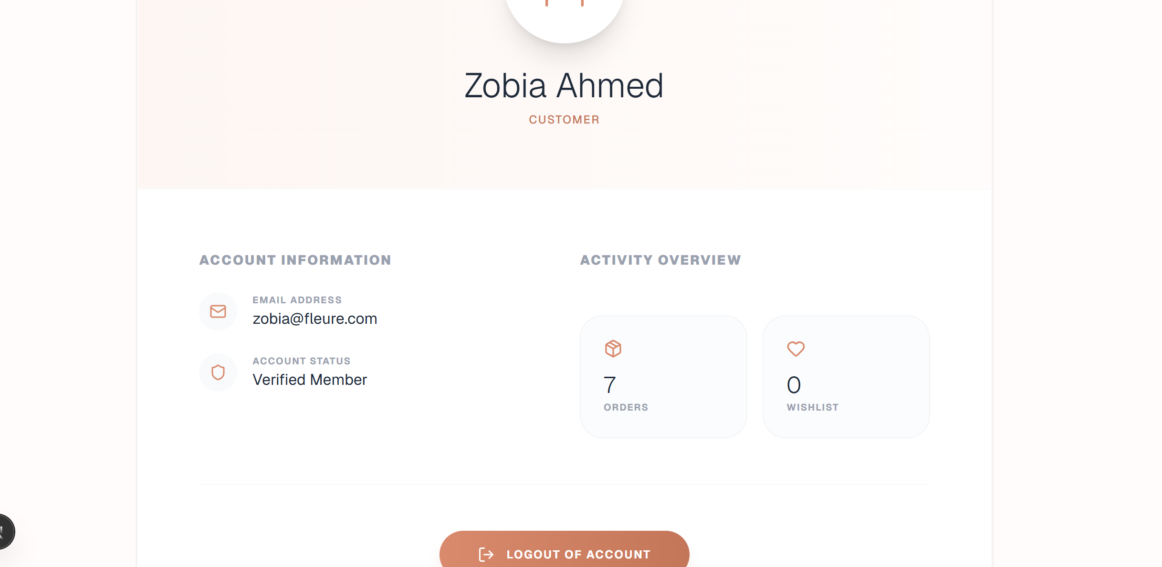
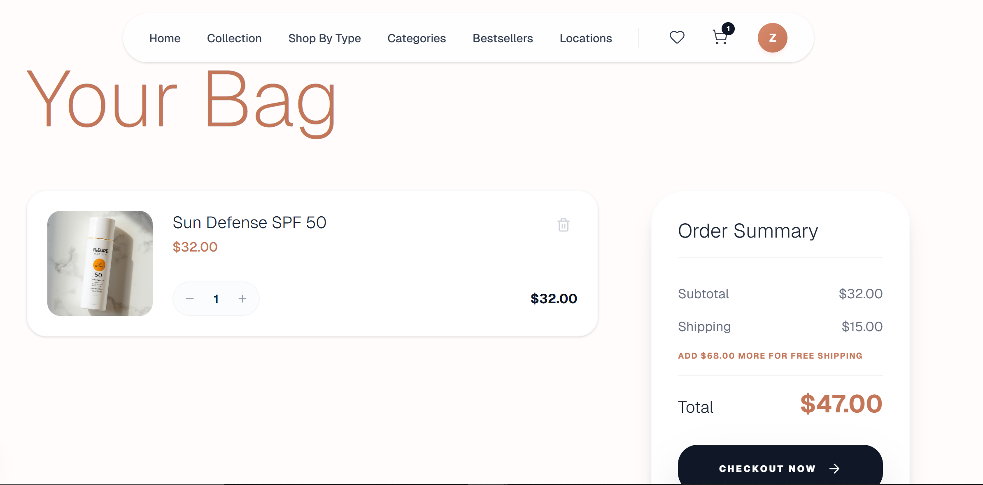
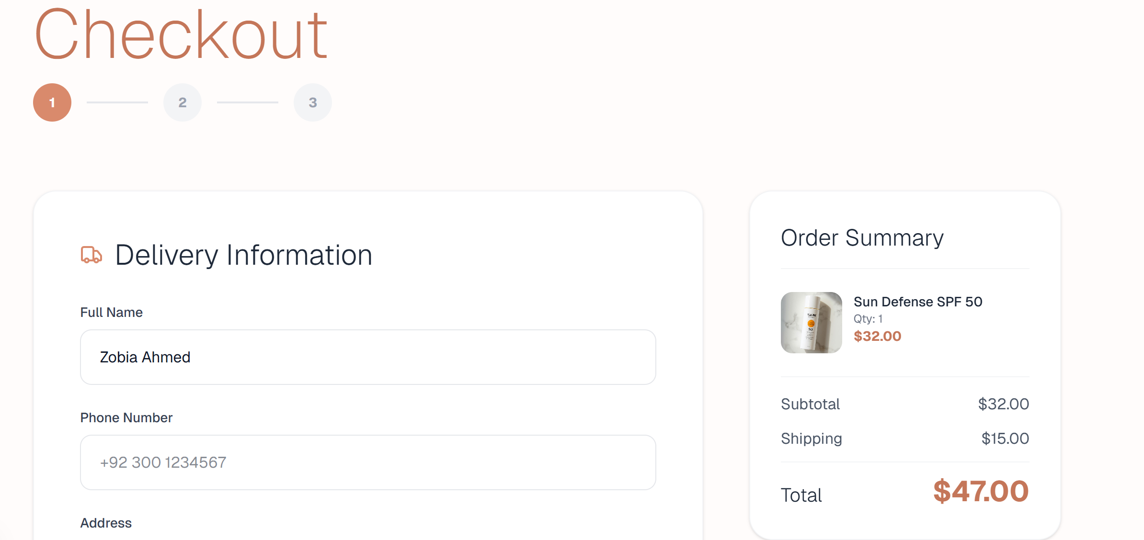
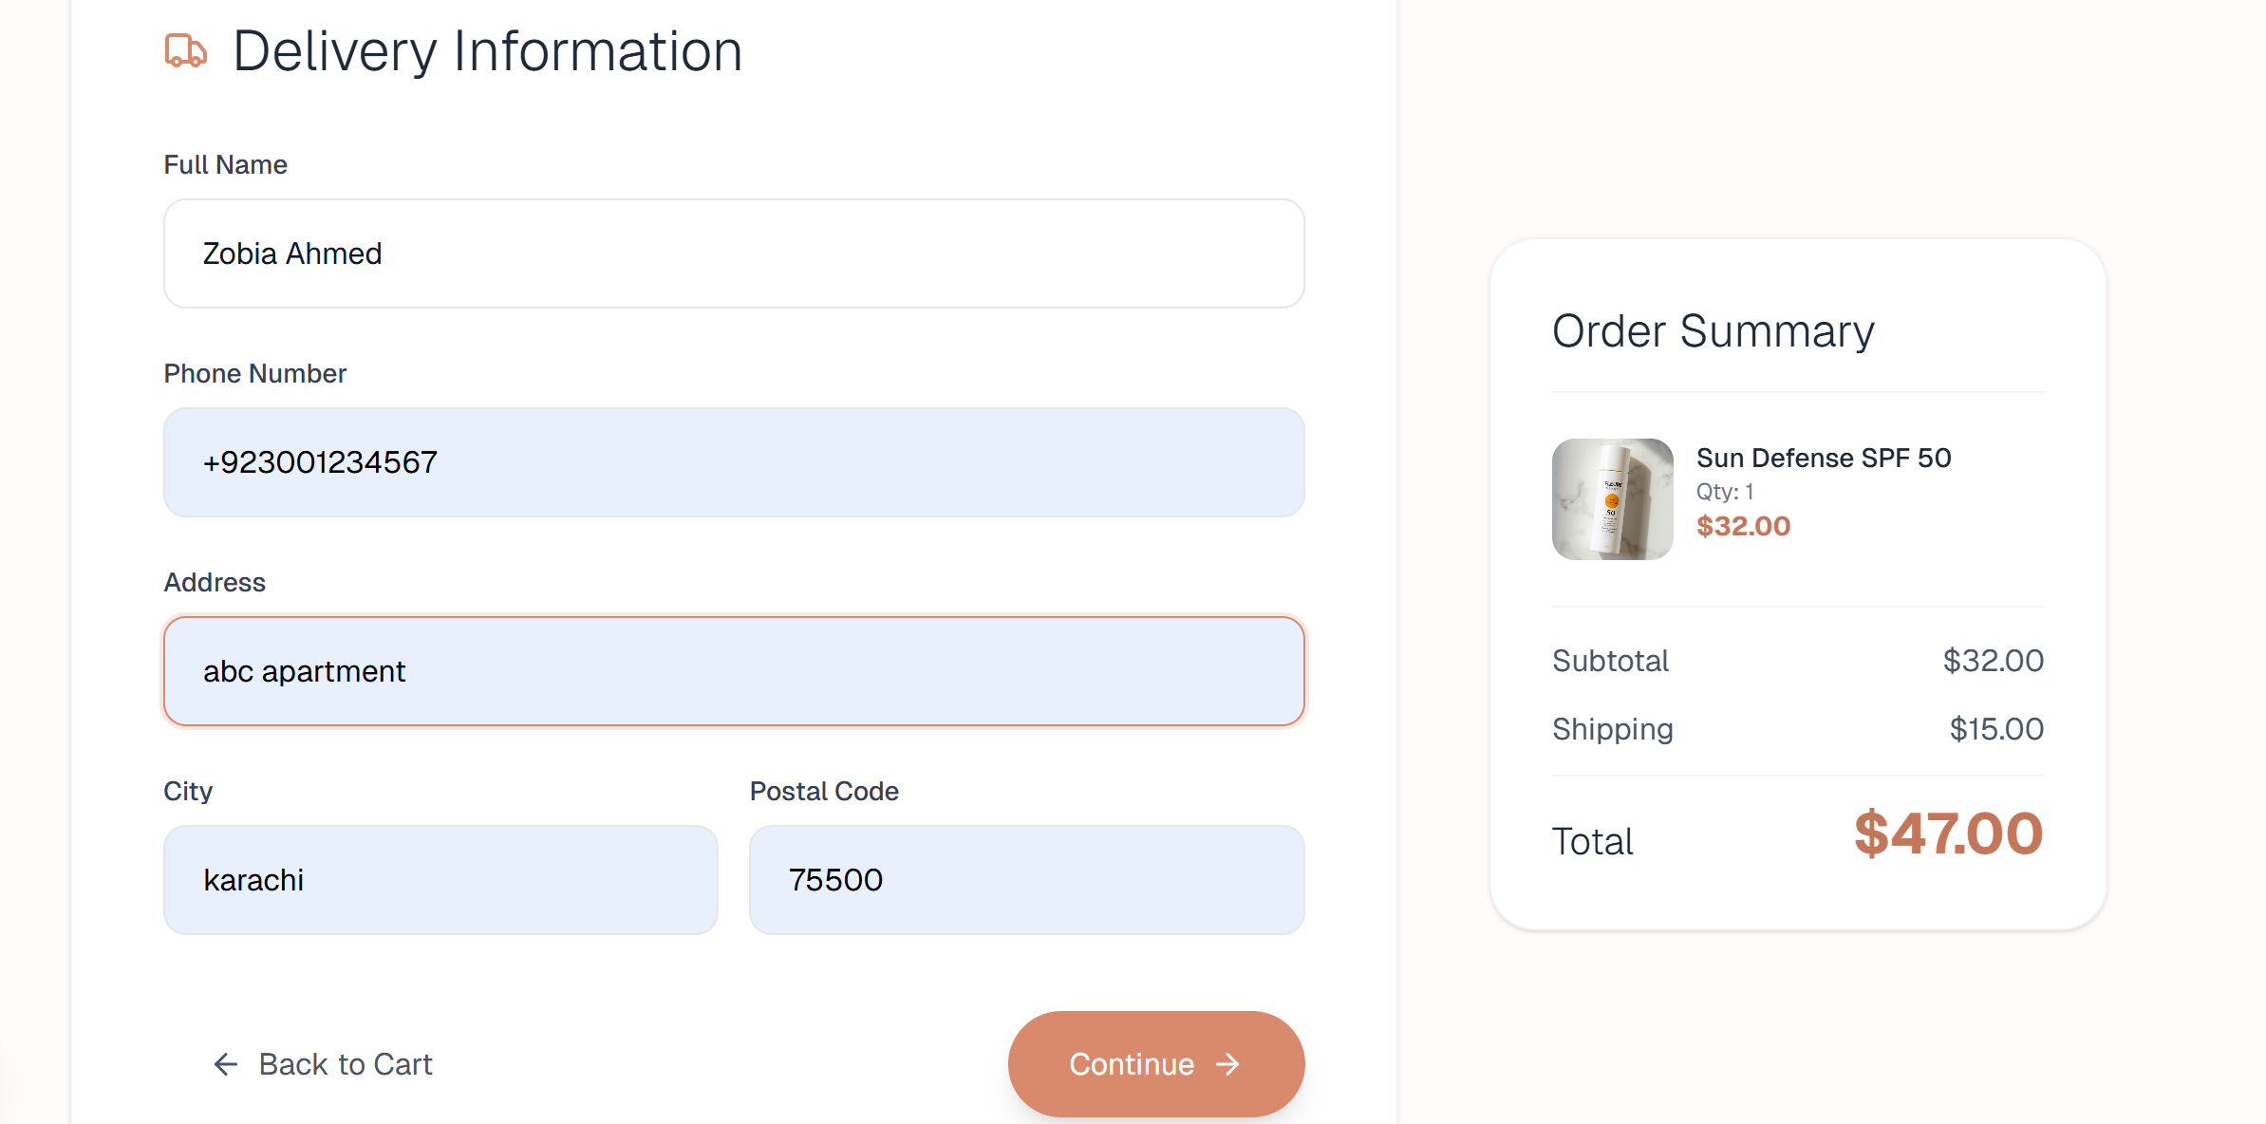
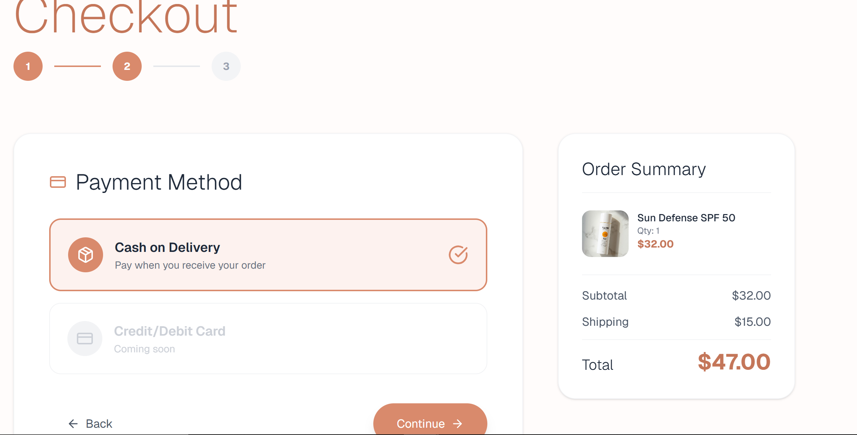
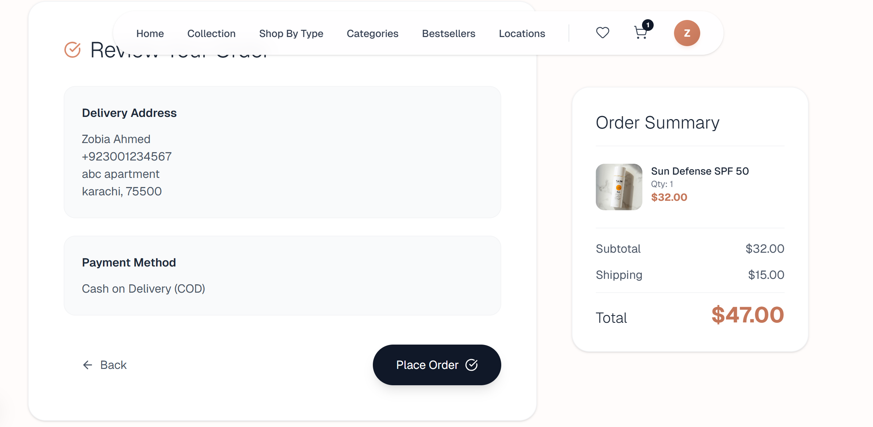
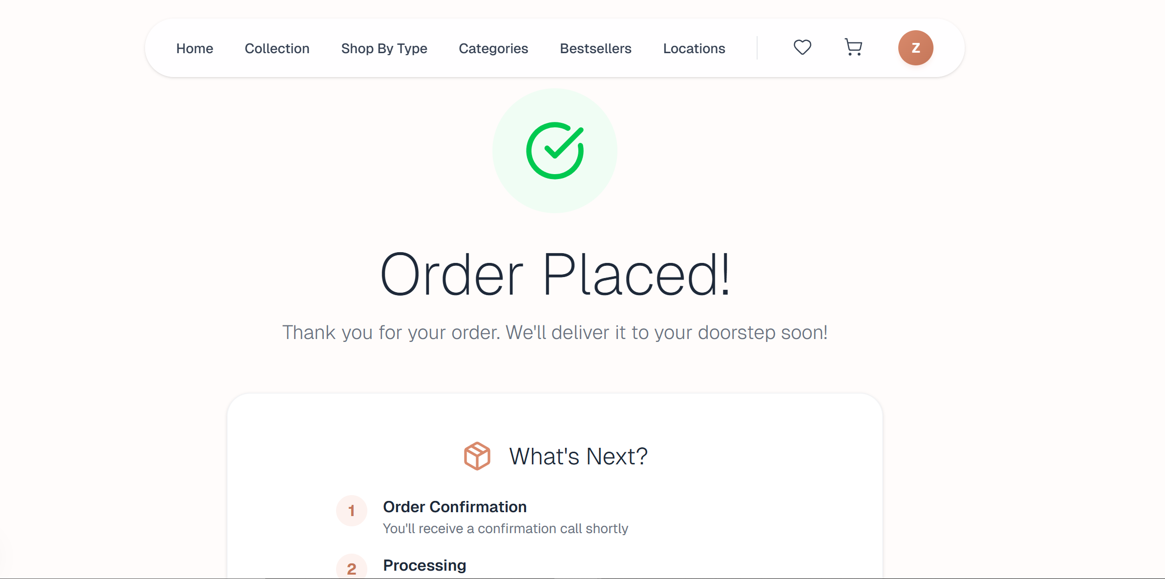
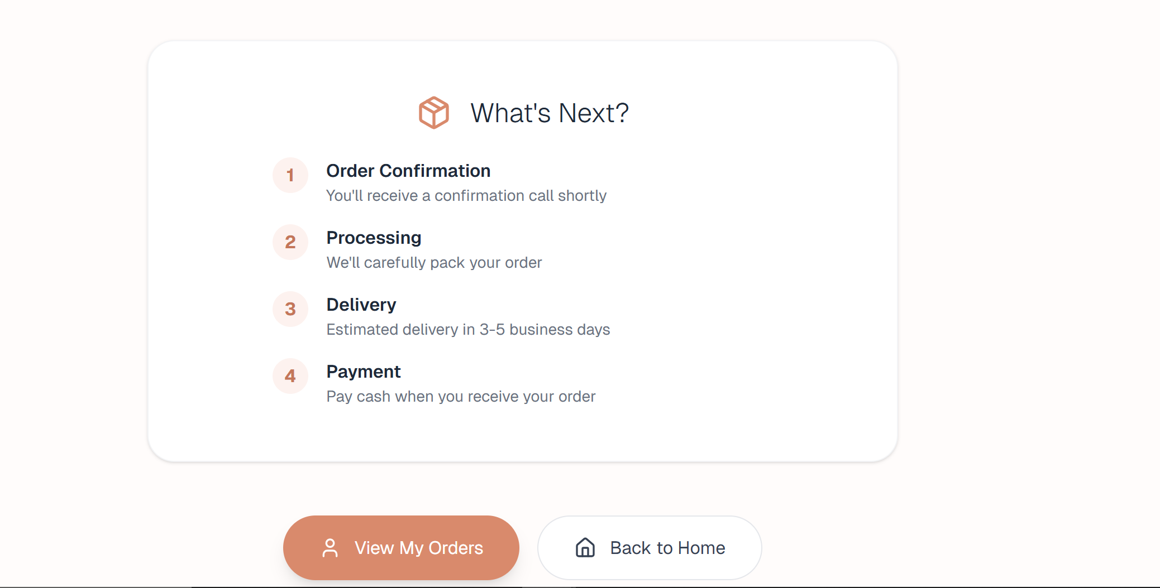

- Reference from other mobile app interface and features:

